**<YourChurch’s Name>**

**logo**

**Safeguarding Children**

**A CHILD PROTECTION POLICY**

**CODE OF CONDUCT**

**and Procedures**

**Section 1. CHILD PROTECTION POLICY**

**1. INTRODUCTION**

**1.1 Policy Statement: A Commitment to Child Protection**

The purpose of this Policy is to guide <the church>in developing a child-protective culture. <The church> is committed to welcoming children and their parents or carers and providing a ‘child-safe’[1] environment, culture and programs for children and other vulnerable people who attend the services and other programs. We see such a commitment as flowing naturally from our vision and mission to operate according to biblical, Christian principles for living and for recognising the unique value and potential of every person, regardless of race, age, gender, ability or disability.

All children who come to <the church> have a right to feel and be safe. The welfare of children in our care will be our first priority. The authorised leaders accept the responsibility of providing a safe and friendly environment where children are listened to, feel safe, have fun, accept challenges, learn and grow. This duty of care applies at all times, although when children attend church and remain with their parents, then the parents have the primary duty of care.

We recognise the particular need for sensitivity for those from culturally or linguistically diverse backgrounds, including those with Aboriginal or Torres Strait Islander heritage. We take into consideration the needs of children with disabilities and seek to include them and make them feel safe and welcome.

This Policy recognises both Federal and State legislation and commits workers to responsibly and reasonably cooperating with Government departments, law enforcement and child protection agencies. The operational principles of our Code of Conduct support and facilitate the protection of children and young people.

**1.2 Scope:**

The provisions and duties of care expressed in this Child Protection Policy apply to:

* Ministers. A minister of religion is: *A person defined or appointed as a recognised leader in an organised religious institution*; or *the appointed leader of a local religious congregation in an organised religious institution who has general authority*.
* The (governing body),
* all employees (including volunteers) members and adherents/regular attenders.
* All activities and programs organised by or with the approval of <the church>, on the premises or off-site, including camps and day trips.
* *All guests or hirers of the venue and its facilities. Such temporary users of the church facilities will be provided with copies of this Policy Code of Conduct and relevant procedures, and the Hiring Agreement will include a signed commitment to complying with the expectations of these documents. (See notes)*
* *Contractors, subcontractors, delivery persons or others engaged to provide services on the premises, particularly if they have any contact with children whilst on site. Where possible, such temporary visitors to the church premises will be provided with an Induction Pack and required to sign their willingness to comply with the expectations outlined. (See notes)*

**1.3 Authority**

This Child Protection Policy and Code of Conduct was revised and updated to reflect the most recent changes to State and Federal law and guidelines towards being a child-safe organisation.

It was approved by the <governing body>. and adopted for use by <the church> on <date>.

**1.4 Policy Review**

The Child Protection Policy, Procedures and Code of Conduct will be reviewed at least every two years, or to remain compliant with new legislation.

Any proposed changes or updates will be submitted to the Board of <the church> for approval at a properly convened meeting for approval before being adopted and implemented.

**1.5 Operating Principles**

***Duty of Care:*** Means any legal responsibility that <the church> has to ensure the safety and wellbeing of those who participate in programs or activities of the church.

***Vicarious Liability:*** Means any legal liability that <the church> may be determined to have for the conduct of those who act on its behalf (e.g. its staff and approved voluntary leaders).

***Reasonable Standard of Care:*** Refers to the level of care that a user may reasonably expect that <the church> will take in providing any program, activity, service, or facility.

***Reasonable Foresight:*** Refers to a responsibility that <the church> has, when planning activities for children and young people, to identify any reasonably foreseen danger/risk and take reasonable steps to prevent or avert such risk.

***Child Protection Reporting Obligations:*** This principle covers mandatory reporting, for those professions and roles that are defined by law, and the moral and legal responsibility that all adults have to report all types of known or possible child abuse, where there is a reasonable belief that a physical or sexual offence has occurred or may be committed against a child

***Reasonable belief:*** A person may form a belief on reasonable grounds, through disclosure by the child or a third party or personal observation of indicators that a child is in need of protection after becoming aware that a child or young person’s health, safety or wellbeing is at risk.

**2. Safety and Participation for Children**

The staff and leadership of <the church> encourage children to feel a part of the church by seeking their feedback regarding children’s programs, and through listening to them when they speak about matters that directly affect their sense of safety or wellbeing.

Part of our work with children is to *teach and inform* them of what they can do if they feel unsafe, threatened or upset by the behaviour of adults or other children. *We will listen to and act on* any concerns children or their parents/carers raise with us.

We value diversity and do not tolerate discrimination in our words or practices or in those of others.

*We are committed to protecting children from harm.* ‘Harm’, as used in this policy, includes any and all of the following types of abuse or neglect of children and young people: physical; sexual; emotional/psychological; racial/cultural or spiritual/religious. (See Appendix 6)

**2.1 Feedback from Children**

Children and young adults will have the opportunity to reflect on their experience of church programs and to make comments regarding the standard of planning for and delivery of programs for their age-group. We will invite comments on other aspects of wellbeing, including staff conduct. Such feedback will inform <the church> and guide adjustments to practices, programs and training. (See Appendix 7)

**3. Employment of Staff and Volunteer Leaders**

**3.1 Recruitment, screening and selection practices**

<The church> will be vigilant in the recruitment, selection and screening of all staff, contractors, leaders and volunteers to ensure they are safe and suitable to work with children and young people. It is important that every person who works with children under the auspices of this church upholds and exemplifies our Christian beliefs and values, especially in their interaction with children and other vulnerable people.

1. Our statements of commitment to child safety and our behavioural expectations of employees and volunteers are included in all advertisements and Job Descriptions.
2. We will conduct thorough screening to determine whether a prospective staff member, contractor, volunteer or leader may pose a risk to children. This will include the church leadership making reasonable efforts to gather, verify and record the following information about a person whom it proposes to engage to perform child-connected work:
   1. Child-related Employment Screening Clearance;
   2. proof of personal identity and any professional or other qualifications;
   3. the person's history of work involving children; and
   4. references that address the person's suitability for the job and working with children.
3. The type of evidence that an applicant is required to provide to the <church> will vary depending on the type of position that they are applying for. However, <the church> will not offer any applicant a position of responsibility until they provide the required evidence to the [insert applicable person].
4. Short-listed applicants will be interviewed by <pastors/activity leaders>, prior to appointment being made official. The Senior Pastor will make appointments to a specific paid role in the form of an Employment Contract.
5. All workers who do not have a current written employment contract are to enter into a ministry/organisational covenant dealing with their suitability to be workers and agreeing to these child protection policies, procedures and the Code of Conduct.

**3.2 Support and Training**

***We provide a system of induction, support and supervision*** *so people feel valued, respected and fairly treated. This system will train and guide our staff and volunteers in their interactions with children and clear procedures for managing programs and activities.*

1. Staff and volunteers are provided with a copy of this **Child Protection Policy**, **Code of Conduct and Procedures** that defines unacceptable conduct, boundaries and expectations for behaviour. Staff will sign a pledge stating they have read, understand and will comply with guidelines and follow procedures faithfully. (See Appendix ?)
2. <Annual> *‘Refresh, Renew, Update’* sessions are run for all program staff and volunteers, to ensure staff and volunteers awareness of the importance of child safety and familiarity with child protective practices and reporting expectations, and where there have been changes to legislation or practice.
3. Paid staff and the leadership team will attend workshop/training sessions organised by the denomination or other Registered Training Organisations.
4. **Reporting and Investigation of Suspected Child Abuse**

Child abuse, especially sexual abuse of a child must be reported, where a reasonable belief is held that the child concerned has been abused, is being or is likely to be abused. A responsible adult can come to a reasonable belief through:

1. Disclosure by a child about abuse to his or her self.
2. Disclosure by another child or an adult about abuse to a child, or
3. Direct observation of the abuse or evidence of it by the reporting adult.

The identity of the abuser and the circumstances of the event determine the procedure that should be followed by the leadership, employees or volunteers of <church>.

* 1. **Abuse of a Child Outside of the Church**

If a child attending a <church> program discloses abuse against them or to another child by a person **outside of the <church>** **community**, then the procedures outlined in **Reporting** **Procedure 1** (Appendix 1 and 1A)must be followed. All such disclosures should be written up on a **Complaints Form** (Appendix 3) and the Child Protection Officer/Senior Pastor informed.

However, it is the duty of the person to whom the disclosure was made to report the matter to either the Police or Child Protection Services (DHHS), following the Reporting Procedure 1. The church leadership may also decide to make a report.

In this case, ***no further investigation by the church is required***. However, all reasonable steps to protect the child from harm should be taken.

**4.2 Abuse of a Child by a <church> employee, volunteer or member.**

In the case of an allegation being made against staff member, volunteer, leader or contractor at <church>, the Child Protection Coordinator will follow the Reporting Procedure in **Procedure 1** (Appendix 1 and 1B) to notify both the church leadership team and either the Police (if the matter is deemed severe or criminal) or the Child Protection Unit of DHHS.

In this case, then the additional requirements of the **Reportable Conduct Scheme** (See Appendix 3) must also be followed by the <head of entity>, summarised here:

<Church> will take all steps to ensure that the safety of the child is paramount.

**Step 1.** Ensure that the details of the allegation are recorded on a church **Complaint Form**, and the Senior Pastor or Leadership Team is informed. Report the matter to the Police or DHHS.

**Step 2.** Withdraw the accused person from active duty, which could entail standing down (with pay, where applicable), re-assignment to other duties that do not have direct contact with children, or to work under increased supervision while the matter is being investigated.

**Step 3.** Notify the ***<state appointed agency to receive Reportable Conduct notifications>*** in accordance with the Reportable Conduct Scheme guidelines, that is, within three (3) working days.

**Step 4.** The investigation process should be completed within 30 days of notification, and the report of the investigation, including findings and actions taken (or decision not to act) will be sent to the <Agency>. In some cases it may be appropriate to bring in an investigator from outside the church, to avoid conflicts of interest.

**Step 5.** When a report is made, the leadership will contact the insurer via GJ Insurance Consulting Pty Ltd. Ph 1300 384 799 or insure@gjic.com.au

**4.3 Investigations**

<Church> will appropriately investigate all allegations relating to an incident of abuse in accordance with its obligations and to the extent reasonably practicable.

In some circumstances, as described by the **Reportable Conduct Scheme**, it may be necessary for <church> to conduct an investigation ***in addition to*** any investigation conducted by authorities (e.g. the police). <The church> may conduct an independent investigation into the allegation to the extent that it will not interfere with investigations by the Department or the police and will co-operate with the authorities as required. All people covered by this Child Protection Policy, Code of Conduct and Procedure must co-operate fully with any investigation by the Department, the police or <the church>.

In some circumstances, it may be appropriate for <the church> to engage a person (or persons) from outside <the church> to conduct an independent investigation in relation to allegations. [2]

<The church> will make every effort to keep any such investigation confidential; however, from time to time other employees, leaders, volunteers and contractors may need to be consulted in conjunction with the investigation (e.g. to provide witness statements).

**4.4 Case management**

In the event of a child disclosing an incident of abuse to someone they trust it is essential that it is dealt with swiftly, sensitively and professionally.

An investigation conducted by <the church> will be conducted in accordance with procedural fairness to protect the integrity of the investigation and the interests of all the participants involved in the investigation. <The church> will also handle the allegations in a confidential manner to the greatest extent possible. The outcome will depend on the findings of the investigation, but may be (but not limited to):

* withdrawal from current role;
* re-assignment to duties with no contact with children;
* increased supervision;
* disciplinary action, dismissal or criminal prosecution.

**5 Risk Management**

<The church> will ensure that child safety is a part of its overall approach to risk management.

Risk assessment and management practices are embedded in our procedures for all services, programs or activities authorised by the church. We use these practices to inform our planning and implementing of all aspects of operation at <the church>.

Risk management applies to Work Health and Safety generally and is covered in more detail in <other policies>. This policy applies specifically to the minimising of risks of abuse of any kind to children who are in our care and to ensuring their physical safety in the buildings or activities of the church. <The church> has zero tolerance of child abuse of any kind.

In situations where a person seeks to attend or join <the church>with a record of offending in child abuse of any kind, the leadership will put in place appropriate boundaries restricting access, to ensure the safety of children. This is not to say that such a person, with a proven reformed attitude, cannot be received into fellowship and benefit from the pastoral care of the church.

<The church> will have <a risk and compliance sub-committee>[3] committed to identifying and managing risks within <the church> and its environment.

If the <Committee> identifies risks of child abuse occurring in <the church> or its environment the committee will make a record of those risks and specify the action(s) the <the church>will take to reduce or remove the risks (i.e. risk controls).

As part of its risk management strategy and practices, the <Committee> will monitor and evaluate the effectiveness of the implementation of its risk controls.

A **Child Protection Officer** is appointed by the leadership for responding to complaints made by staff, contractors, volunteers, children or other attendees and members of the congregation.[4]

The Child Protection Officer (CPO) will be identified and their role explained at appropriate times in the church year. Guests, staff and volunteers are expected to use either the **Complaints Form** or the **Incident Form** to note concerns arising from observations or experience. (See Appendices 2 and 4) Copies of these forms will be kept in the Church Office by the CPO.

**6 Record Keeping**

All reports of alleged abuse or harm, or risk thereof, must be recorded in the form of a Complaint or Incident Report. This will record places, times, dates, names of people, observable behaviours or evidence of harm. Reports must be to be securely stored by the CPO. The provide valuable legal documents for any investigations and demonstrate the churches due diligence.

**7 Privacy and Confidentiality**

<The church> will collect, use, disclose and hold personal information of all people who fulfil a role within the church, in accordance with relevant privacy legislation. Such data will be securely stored and protected.

As much as is reasonably possible, an individual’s confidentiality is to be protected. Both those who are making reports and those about whom accusations are being made are entitled to confidentiality. Where there is suspected abuse or misconduct, staff members, leaders, volunteers and contractors must not disclose or make use of the information in a manner that breaches confidentiality, other than to report and act in a way consistent with the Child Protection Policy, Code of Conduct and Procedure, and relevant statutory requirements.

**Section 2. CODE OF CONDUCT**

**1.1 Purpose:**

<The Church> is a group of followers of Jesus Christ in (suburb/locality) seeking to reflect the teachings of Christ and of the New Testament with integrity and humility. We accept that our faith is worked out and expressed in the quality of relationships we develop as a church community and all those with whom we interact in our daily lives. Jesus summarised God’s expectation for the conduct of His people into one famous and succinct sentence: *‘You shall love the Lord your God with all your heart, soul, mind and strength, and your neighbours as yourself.’* He reinforced this ‘law of love’ by adding, *‘By this shall all men know that you are my disciples; you love one another!*’ Jesus also taught and demonstrated the importance of truth and honesty, of justice and mercy as essential to healthy relationships.

This **Code of Conduct** seeks to apply to the ministerial, or pastoral relationship those ethical standards that God expects of all people. People in various forms of recognised ministry are therefore expected to be examples and models of Christian faith and practice. It is the duty of any person in a ministry position not to use the influence or authority of their position for personal gain, whether that gain is financial or in terms of power, sexual gratification, or otherwise. This includes any action, verbal, written or electronic, physical or emotional that could be interpreted as emotional, sexual or spiritual abuse, and applies especially when working with children. We recognize the power differential between children and adults in ministry roles, and these guidelines seek to ensure that such a power is not used to harm children or any vulnerable person.

The adoption of this **Code of Conduct** and the related **Procedural Documents** for investigating breaches of the Code, reflects a deep desire for an open, accountable process that seeks to express justice, acceptance and compassion to all parties, rather than to protect the organization.

**1.2 Our Commitment**

Our commitment to expressing the love of Christ leads us to the view that all people should be able to live, work and learn in an environment that is free from abuse of any kind. Our commitment is to cultivate an environment and culture where a diversity of people, regardless of age, gender, race and culture can thrive and grow holistically. That is, we are committed to <the church> being a safe place for all people, with a special focus on the safety and wellbeing of children.

This **Code of Conduct** aims to detail the standards of conduct expected by staff (paid and voluntary) in the performance of their duties in working with children and to provide guidance in areas where there is a need to make personal and ethical decisions.

The **Code of Conduct** recognises and is aligned with all statutory and compliance requirements enshrined in State and Federal law. <The church>is committed to operating in accordance with the law in all its operations.

**2. Specific Expectations to Protect Children from Abuse**

All those who minister or work under the auspices of the church with children should be fully aware of the **Child Protection Policy** and **Code of Conduct.** Abusive behaviour towards children will not be tolerated. Any and all allegations will be investigated and reported if found to be substantially true.

**2.1 DO:**

* contact the police if a child is at immediate risk of abuse (telephone ‘000’);
* adhere to the Child Protection Policy and Procedure and uphold the <the church>’s commitment to child safety at all times;
* take all reasonable steps to protect children from abuse, recognising you duty of care;
* conduct themselves in a manner consistent with their position as an employee, volunteer, leader or contractor of <the church> and as a positive role model to children and young people;
* work towards the achievement of the aims and purposes of <the church>;
* be responsible for relevant administration of programs and activities in their area;
* establish and maintain a child-safe environment in the course of their work;
* be fair, considerate and honest with others;
* treat children and young people with respect. Value their ideas, opinions and consider their age, background and abilities;
* promote the cultural safety, participation and empowerment of **Aboriginal and Torres Strait Island** children (for example, by never questioning an Aboriginal and Torres Strait Island child’s self-identification);
* promote the safety, participation and empowerment of children with **culturally and/or linguistically diverse** backgrounds (for example, by having a zero tolerance of discrimination);
* promote the safety, participation and empowerment of **children with a disability**;
* listen and respond to the views and concerns of children, particularly if they are telling you that they are or another child has been abused or that they are worried about their safety/the safety of another child;
* ensure (as far as practicable) that adults are not alone with a child, or, at least, observable by another adult.
* raise concerns about suspected abuse with the Child Protection Officer or a leader as soon as possible;
* comply with all reporting obligations as they relate to reporting under legislation;
* record and act upon all allegations or suspicions of abuse, discrimination or harassment;
* if an allegation of child abuse is made, ensure that, as quickly as possible, the immediate and ongoing safety of the child or children;
* be professional, consistent and responsible in all your actions;
* maintain strict impartiality;
* respect confidentiality when sharing information about children in accordance with the Child Protection Policy and Procedures and your reporting obligations;

**2.2 DO NOT:**

All people involved in the care of children on behalf of <the church> must not:

* ignore or disregard any suspected or disclosed child abuse;
* put a child at risk of abuse (for example, by locking doors for an improper reason);
* speak to a child in a way that is or could be construed by any observer as harsh, threatening, intimidating, shaming, derogatory, demeaning, or humiliating. Some examples are:
  + swearing or using inappropriate language in the presence of a child;
  + yelling at a child, except in an emergency situation where the child’s safety may be in danger;
  + dealing with a child in anger; and
  + using hurtful sarcasm.
* discuss sexual activities with a child, unless it is a specific job requirement and the person is trained or qualified to discuss these matters;
* have private contact with a child outside of church activities without the knowledge and/or consent of <the church>’s leadership;
* have any online contact with a child (including by social media, email, instant messaging etc.) or their family (unless necessary and approved by the church and the child’s parents/guardians);
* use any personal communication channels/devices such as a personal email account or social media to communicate with a child without parental knowledge;
* exchange personal contact details such as phone number, social networking sites or email addresses with a child (unless necessary and approved by the church and the child’s parents/guardians as the agreed form of communication);
* use, possess, or be under the influence of alcohol while in the presence of or while supervising a child (unless your contact with the child is accidental/incidental and you are not performing your duties as directed by <the church>);
* use, possess, or be under the influence of illegal drugs while in the presence of or while supervising a child;
* provide or allow a child to consume alcohol;
* provide or allow a child to consume illegal drugs;
* initiate unnecessary physical contact with a child or young person, or do things of a personal nature for them that they can do for themselves;
* engage in rough physical games, hold, massage, kiss, cuddle or touch a child in an inappropriate and or/culturally insensitive way;
* engage in any sexual contact with a child for any purpose;
* take a child to your home or encourage meetings outside program activities (unless necessary and approved by the church and the child’s parents/guardians);
* be naked in the presence of a child;
* possess sexually explicit printed materials (magazines, cards, videos, films, clothing, etc.) in the presence of children;
* sleep in the same bed, sleeping bag, room or tent with a single child;
* discriminate against any child, on the basis of age, gender, race, culture, sexuality, or disability;
* engage in any activity with a child that is likely to emotionally harm them (e.g.watch a movie that is age or content inappropriate for a child);
* be alone with a child unnecessarily and for more than a very short time, unless you are observable by another adult or it is unavoidable;
* develop a ‘special’ relationship with a specific child for their own needs;
* show favouritism through the provision of gifts or inappropriate attention;
* photograph or video a child without the consent of the child and his/her parents or guardians;
* do anything in contravention of <the Church>’s policies, procedures or this Code.

**DECLARATION**

I, _________________________, have read the Code of Conduct and the Child Protection Policy and Procedures that express the intent of the church to protect and nurture children and other vulnerable people.

I agree to comply with these rules and expectations. I understand that if I breach the Code of Conduct or commit an act of serious misconduct or break the law, this may lead to my:

* suspension from duties during investigation of allegations against me;
* termination of employment without notice or payment in lieu (summary or instant dismissal);
* being reported to the police and charged with a criminal offence.

Signed: _____________________________________ Date: ____ / ____ / 20___

Signed: _____________________________________ Date: ____ / ____ / 20___ <Employer or Senior officer of the Church>

**Section 3. CHILD PROTECTION PROCEDURES & FORMS**

**3.1 Complaints and Allegations**

Any person who believes a child is in immediate risk of abuse should telephone 000.

Certain professions are referred to as ‘mandatory reporters’. This includes medical practitioners, nurses (including school nurses), members of the police force, counsellors and primary and secondary teachers and principals. Penalties may be incurred by those named as ‘mandatory reporters’ if they fail to notify the Child Protection agency if they have reasonable grounds for a belief (not proof!) that a child or young person is in need of protection, because they have suffered, or are likely to suffer significant harm, particularly physical or sexual abuse.

In addition to the mandatory reporting obligations above, **any person** who believes on reasonable grounds that a child is in need of protection from child abuse, should disclose that information to the Police or the Child Protection. In Victoria ‘Failure to Report’ is a crime!

**3.2 When is a child in need of protection?**

A child is in need of protection if any of the following grounds exist—

1. the child has been abandoned by his or her parents;
2. the child's parents are dead or incapacitated and there is no other suitable person willing and able to care for the child;
3. the child has suffered, or is likely to suffer, significant harm as a result of physical injury and the child's parents have not protected, or are unlikely to protect, the child from harm of that type;
4. the child has suffered, or is likely to suffer, significant harm as a result of sexual abuse and the child's parents have not protected, or are unlikely to protect, the child from harm of that type;
5. the child has suffered, or is likely to suffer, emotional or psychological harm of such a kind that the child's emotional or intellectual development is, or is likely to be, significantly damaged and the child's parents have not protected, or are unlikely to protect, the child from harm of that type;
6. the child's physical development or health has been, or is likely to be, significantly harmed and the child's parents have not provided, arranged or allowed the provision of, or are unlikely to provide, arrange or allow the provision of, basic care or effective medical, surgical or other remedial care.
   1. **Making and Managing an Allegation of Abuse**

**1**. Where possible, any person (including a child or parent) making an allegation of child abuse should be encouraged to fill out a **Complaints Form** (Appendix 2) and give this to the CPO. If they are not willing or able to fill out the Form, the CPO (or other leader) may take notes and fill out the form at a later time. The CPO **will** share the allegation with the senior leader of <the church>. A copy of this Form **must** be kept by the CPO. The complainant may keep the original. This is an essential record of the event.

If a child is concerned about their own safety or the safety of another person, the child may speak to the **Child Protection Officer (CPO)**. The CPO will meet with the complainant, and hear the story, taking notes and seeking clarification, ensuring that the complainant feels listened to, understood and protected. (Some complaints may be able to be dealt with at this time, where there is misunderstanding, a lack of evidence of any abuse or no reportable act has been committed.)

2. Any responsible adult should, if they have come to a reasonable belief that abuse of a child has happened, is or is likely to happen, follow the steps outlined in **Reporting Procedure 1** (Appendix 1A) below. This includes senior leadership, or any concerned member of the church.

3. If the allegation is made against an employee, volunteer or worker in a church program or activity, then the <head of entity> must ALSO follow the steps outline in **Reporting Procedure 2:** (Appendix 1B)

**Appendix 1. Reporting Procedure 1**

**1. Clarifying, Recording Evidence and Specific Information about the Child**

*A Report is required if you believe, based on reasonable grounds, that a child has suffered, or is at risk of suffering, significant harm as a result of physical, sexual, emotional abuse or neglect AND that the child’s parents or caregivers have not, or are unlikely to, protect the child from such harm.*

The following information will be required when making a formal report to either the Police or Child Protection Services.

* The child’s name, age (date of birth is preferable) and address
* The name, age and address of any known siblings
* Your reasons (observations or disclosures) for believing that the child is at risk of abuse, or actually being abused or neglected
* Your assessment of the immediate danger to the child
* Current whereabouts of the child or vulnerable person (if not in the home)
* Your description of injuries or ‘sign’ behaviours you have observed
* Any other information you may have of relevance to the investigation

**2. Fill out a Complaints Report Form (Appendix 3)**

*N.B. You do not have to be given permission by church authorities to make such a report. Your identity as notifier will remain confidential unless you choose to inform the child or family.*

**3. Reporting.** Making a report is to lay a serious allegation of a criminal offence against another person, so clarify your perceptions carefully before reporting.

You can make your report to:

* **<The church> Child Protection Officer**, using a Complaint Form. Attach your notes to the form, keeping a copy. Please note, the CPO will inform the senior leadership of the church of your report, and they will act in accordance to law. You may still make an independent report to:
* **The Police.** (Ring 000) The police are the most appropriate first responders if the report is regarding abuse that is immediate, criminal or endangering the child either on church premises in another location.
* **Child Protection Services <insert the correct phone number for your stateor territory>**

Victoria: (1300 655 795 BH, or 13 12 78 AH) is a statutory service provided by DHHS to protect children and young people at risk of harm and to work with families to ensure these risks are mitigated.

**Appendix 1A Reporting Procedure 1**

**Appendix 1 B Reporting Procedure 2.**

**

**APPENDIX 2. Complaint Report Form (Example only)**

Please use this Form to make a Formal Complaint regarding discrimination or abuse of any kind towards yourself or another person, including a child.**Please read the Code of Conduct Document before using this form.**

**COMPLAINT FORM (Private and Confidential) Date: / /201__ Time: ___:____ am/pm**

|  |  |
| --- | --- |
| **Your Name: ____________________________** | (If applicable)  **Role at < the church>: _____________________** |
| Is the complaint about offending behaviour:  a. Directed towards you? **Yes / No**  b, Concerning a child?**Yes / No**  c. About a vulnerable person? **Yes / No** | Who was the victim of the behaviour?  **Name: __________________________**  **Date of Birth: ___ / ____ / _______ Age:____**  **Address: ________________________________** |
| Please briefly, but accurately, describe the alleged behaviour about which you are lodging this Complaint Report Form. (Keep to the facts, without interpretation or opinion.)  **Who was the offending person? ____________________________________________________**  **What abusive behaviour did you observe or come to hear about? _____________________________**  **___________________________________________________________________________________**  **___________________________________________________________________________________**  **Is the abuse still happening or was it a past event? ________________________________­­­­­________**  **Is there any physical evidence of abuse – is the child injured? _______________________________**  **__________________________________________________________________________________**  **Where did the event/behaviour take place? _____________________________________________**  **____________________________________________________________________________________**  **Were there other witnesses? If so, provide name(s) _______________________________________**  **__________________________________________________________________________________**  **What is the level of risk to the victim now? (Low – High; Immediate – possible)**  **__________________________________________________________________________________**  **Any other comments: ________________________________________________________________**  **__________________________________________________________________________________**  **___________________________________________________________________________________** | |
| **Statement of Intent:** I make this complaint in all sincerity, recognising that such a complaint may have a serious or long-term impact on all those involved. I will act in good faith in the process and accept the ruling of the investigator where I believe it is fair and transparent.  **Signed: __________________________________ Date: ______ / _____ / 20____**  **Witness: (Print name)_________________________________ Date: ______ / _____ / 20____**  **Signature: ________________________________** | |

**APPENDIX 3. Managing Complaints and Investigations**



**Appendix 4. THE REPORTABLE CONDUCT SCHEME (Victoria)**

THE REPORTABLE CONDUCT SCHEME outlines a series of responsibilities for the ‘head of entity’ (Senior Pastor) to undertake, where an allegation has been made about child abuse against a person who is acting for the church or participating in activities run by the church.

The following information is provided by the **Commission for Children and Young People.**

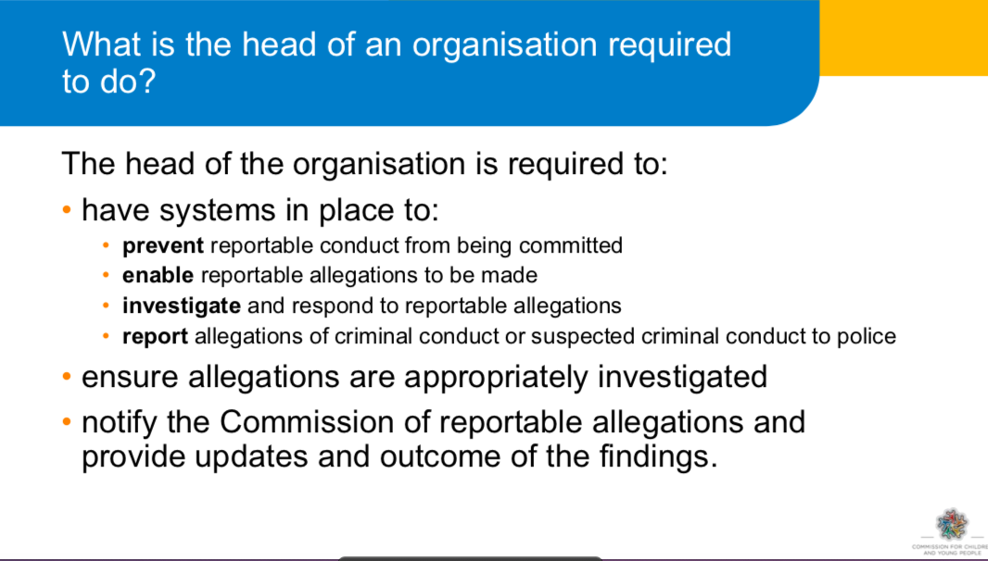

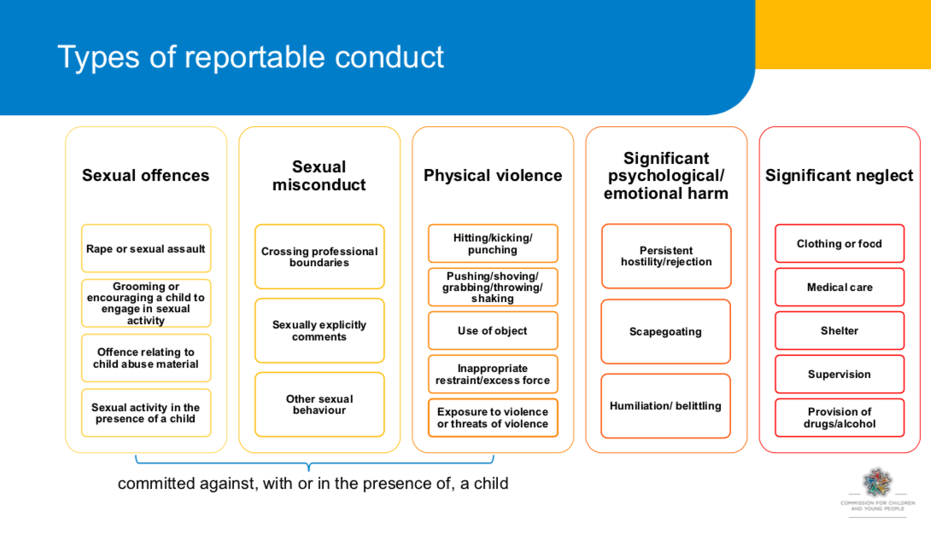

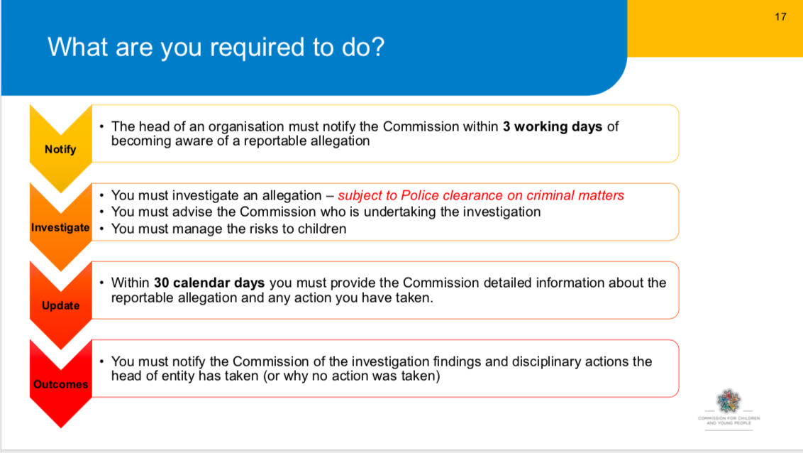

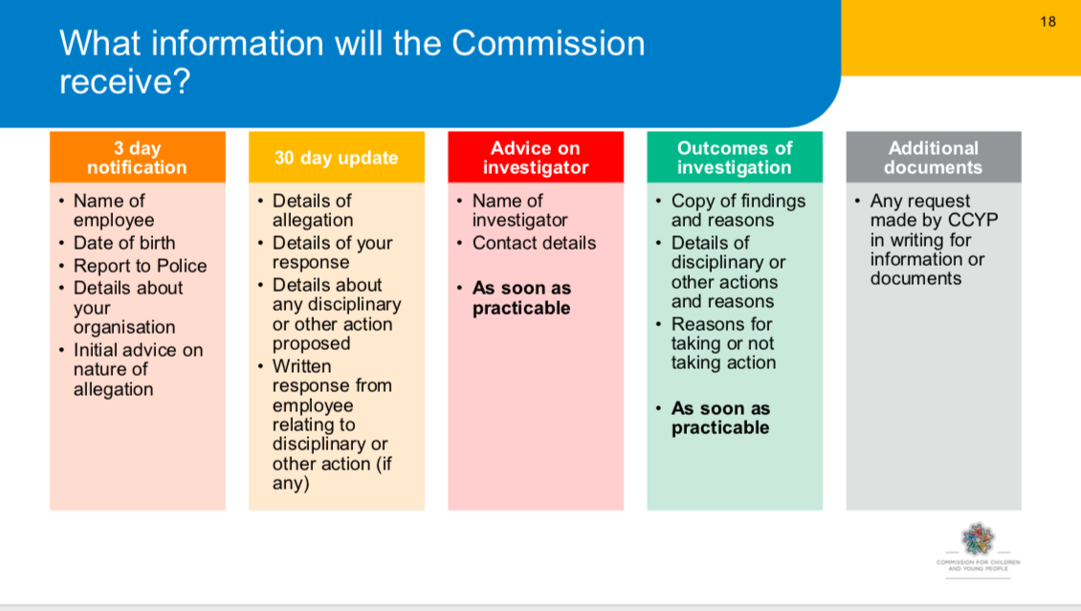

A more complete outline of the elements of the Reportable Conduct Scheme can be found at:

<https://ccyp.vic.gov.au/child-safety/resources/reportable-conduct-scheme-information-sheets/>

**APPENDIX 5 INCIDENT REPORT [Example only]**

This form is to record the details of any incident involving the writer of the report, especially where there was an accident, near miss or emotional reaction involving another person, or if the writer of this report has been accused of child sexual abuse or other misconduct.

Name: _________________________________________ Phone contact: ______________________

Date of Incident: _____/ _____ /201__ Time of Incident: ___________________am /pm

Location of Incident on Site: _____________________________________________________________

Name (s) of anyone else involved in the incident: ____________________________________________

Provide the name and contact details of any witnesses of the incident who can provide additional evidence or view.

1.Name: ______________________________________ Mobile: ______________________________

2. Name: _____________________________________ Mobile: ______________________________

Please describe what happened, your actions and/or words and the actions and/or words of others involved. Do not give your opinion about other’s motives or intentions. (PTO if necessary)

.

.

.

.

.

.

.

.

.

.

.

.

.

.

.

.

.

.

.

.

I, (Print name): ______________________________ hereby declare that what I have written is true and accurate in the details I have provided.

Signed: ______________________________________ Date: ____ / _____ /201__

**APPENDIX 6 Definitions of Abuse against Children**

**Child abuse includes:**

Any act committed against a child involving

1. a sexual offence; or
2. an offence under section 498(2) of the Crimes Act 1958 (grooming); and
3. the infliction, on a child, of-
   * 1. physical violence; or
     2. serious emotional or psychological harm; and
4. serious neglect of a child.

“Child” means a person under the age of 18 years unless otherwise stated under the law applicable to the child. Collective term for “child” is “children”.

There are five common types of abuse: physical, sexual, emotional, neglect and racial/cultural

1. **Physical Abuse**

Physical abuse is any non-accidental physical injury resulting from practices such as:

* Hitting, punching, kicking, beating (marks from belt buckles, fingers).
* Shaking (particularly babies).
* Burning (irons, cigarettes), biting, pulling out hair.
* Alcohol or other drug administration.

1. **Sexual Abuse, including ‘grooming’**
   1. **Sexual abuse** is any sexual act or threat to perform such upon another person. It occurs

when a person uses their power and authority to take advantage of another’s trust to involve them in sexual activity. It does not necessarily involve genital contact but is any act which erodes the sexual boundary between two persons. It may appear consensual but the validity of consent is negated by the power differential.

* 1. **Sexual grooming** is a pattern of behaviour aimed at engaging a child, as a precursor to sexual abuse. Examples include inappropriate special time with the child, inappropriately giving gifts, ‘accidental touching’, allowing the child to sit on lap, having secrets. In isolation, such behaviours may not indicate the risk of abuse occurring, but if there is a pattern of behaviour occurring, it may indicate grooming.

Grooming behaviours often mimic the kind of relationship-developing strategies that Christian ministries use for the benefit and wellbeing of children, that is, gaining the trust of the child, demonstrating care and concern, spending time, visiting in the home, finding out about family, friends and hobbies. However, grooming to involve a child in sexual activities for the personal gratification of an adult is a crime.

1. **Emotional or Psychological Abuse**

Emotional abuse is the chronic attitude or behavior of one person, which is directed at another person, or, the creation of an emotional environment which erodes a child’s development, self-esteem and social confidence over time. Behaviours may include: devaluing, ignoring, rejecting, corrupting, isolating, terrorising or chronic and extreme domestic violence in the child’s presence.

1. **Neglect**

Neglect is characterised by the failure to provide for the child’s basic needs. And includes any serious omission or commission which jeopardises or impairs a person’s development. Examples include the failure to provide food, shelter, adequate hygiene or schooling for a child.

1. **Bullying**

Bullying can be defined as repeated, unreasonable, unwanted behaviour conducted by an individual or group against another person, which has a negative impact on health and wellbeing. This includes aggression, verbal, emotional/psychological or physical acts or the use of social media or other forms of communication that intimidates, humiliates or threatens. It often involves an abuse of a power differential between the bully and the victim.

**Other Forms of Abuse**

1. **Racial, cultural or religious abuse**

Racial abuse is any harmful conduct that discriminates against, or demonstrates contempt, ridicule, hatred or negativity towards a child because of their race, ethnic origin, skin colour or other evidence of ‘difference’. It may be overt, such as racial vilification or discrimination, or covert, such as demonstrating a lack of cultural sensitivity or positive ideas about a different ethnicity.

Religious or cultural abuse is similar to racial abuse, but is directed towards expressions of religious faith or practice or cultural dress, identifying styles of cultural expression or practices.

*‘The harm that is caused by racial, religious or cultural abuse targets the child’s* ***identity****.’*

1. **Spiritual abuse**

This involves the perpetrator using their position of authority in the church or higher understanding of biblical teaching or God’s will to manipulate a child for their own use or benefit, or to pressure a child using guilt, shame, or a strong “works” based ethic. This is not reportable to a Government Child Protection agency, although in extreme circumstances can be classified as emotional abuse.

**Cyber-bullying**

Cyber-bullying occurs when a person uses any form of telecommunication to sexually groom, bully, suggest an inappropriate relationship be formed, or engage a child in sexual language or behaviours. The explosion of electronic communications (Facebook and other social media sites, text-messaging, internet chat rooms etc.) has seen a sharp increase in cyber-bullying.

### Statistics of Abuse

It is very difficult to know precisely the amount of child abuse that occurs in Australia, as many acts go unreported. Statistics of reported acts, though, are available through government agencies. Child Protection Australia 2010-11 report reported that there were 237, 273 notifications of child abuse involving 163,767 children in Australia..[5] The Australian Institute of Health and Welfare (2002) revealed the following breakup of perpetrators: 74% natural parent, 10% step-parent or de facto, 7% other relative or sibling, 5% friend or neighbour, 4% others (including strangers).[6] The reality of abuse in Australia is a lot worse than the statistics. There are estimates that as many as 1 in 20 men in Australia may sexually offend against a child. As many as 1 in 5 children will be sexually abused during their childhood. On average, it takes a girl 7 years to tell someone about such abuse, and for men the average is well over 25 years, if they ever do.

**APPENDIX 7 (Example) Feedback Survey of Children. Name:_________________**

This survey is your chance to have a say about the children’s programs. Think about each statement and mark on the line, somewhere between “Not at all!’ and ‘Absolutely!’.

1. **I feel welcomed and looked after when I come to this church..**

I__________________________________I_____________________________________I

Not at all. Mostly Absolutely!

1. **My parents like and follow the log-in process and arrangements for my care.**

I__________________________________I_____________________________________I

Not at all. Mostly Absolutely!

1. **I know which toilets to use and feel safe when using them.**

I__________________________________I_____________________________________I

Not at all. Mostly Absolutely!

1. **There are good spaces for activities and learning times.**

I__________________________________I_____________________________________I

Not at all. Mostly Absolutely!

1. **The activities are fun, challenging and well-organised.**

I__________________________________I_____________________________________I

Not at all. Mostly Absolutely!

1. **I feel safe and relaxed while I am in the children’s programs.**

I__________________________________I_____________________________________I

Not at all. Mostly Absolutely!

1. **I feel that the leaders know what they are doing and are looking after me.**

I__________________________________I_____________________________________I

Not at all. Mostly Absolutely!

1. **The leaders are friendly and respectful of my friends and me.**

I__________________________________I_____________________________________I

Not at all. Mostly Absolutely!

1. **If I am worried or upset, I know who I can go to for help.**

I_______________________________I___________________________________I

Not at all. Mostly Absolutely!

1. **I would recommend this church program as great for kids.**

I________________________________I___________________________________I

Not at all. Mostly Absolutely!

Appendix 8

MEDICAL & HEALTH INFORMATION – SPECIAL EVENT (EXAMPLE)

…………………………….…………………**(**Insert organisation name)**

Child’s Name:

(Surname) (Christian name) Date of Birth

Is your child taking any regular or currently prescribed medication? YES / NO

If so, please name the medication and provide details of dosage and administration.

Your child’s leader will administer medication to your child as directed by written instructions from you. Please clearly mark your child’s name on all medication along with the dosage and administration procedures.

Is there anything about your child’s health which means that s/he should engage in only limited physical activity? YES / NO

If so, please give details

Does your child require a special diet because of health problems? YES / NO

If so, please give details

Is there any other information which may help us care for your child? YES / NO

If so, please give details

Emergency contact 1. Name: ___________________________________ Mobile: _______________________

Emergency contact 2. Name: __________________________________ Mobile: _______________________

Preferred Medical Centre/ Doctor: ______________________________________ Phone: ________________

Do you have private medical insurance? Provider: ________________________________________________

**AUTHORISATION**

‘In the event of an accident or sudden illness, I authorise the person in charge to call an ambulance or to seek medical attention at my expense, should I not be contactable.’

Signed: ______________________________________________ Date: ___/____/20___

Parent/guardian/caregiver [Print name if not one of the above] _______________________________

Witness Name: _______________________________ Signature: _____________________________________

Appendix 9 Example Permission Form

PERMISSION TO ATTEND EVENT/CAMP FORM (EXAMPLE)

…………………………….…………………**(**Insert organisation name)**

As a parent/caregiver of:

I, give my consent for him/her to take

part in the <special activity or camp> to be held at the (event site)

from to (or on )

*(date) (date) (date)*

I have seen the attached copy of the programme for the (event)

and acknowledge that risk of injuries is inherent in physical activities. While I am aware that staff will take all due care, I recognize that accidents may occur.

The staff and supervisors have my authority to take whatever action they think necessary to ensure the safety, wellbeing and successful conduct of the participants as a group or individually in the above-mentioned activity.

If my child becomes ill or is accidentally injured, I authorise the person-in-charge to obtain on my behalf whatever medical treatment my child requires. I will agree to pay all such medical expenses.

I have attached information as asked concerning my child’s health including any relevant details of his/her limitations for the planned activity. My child’s own local doctor or medical specialist may be contacted in an emergency.

I also acknowledge that the <Church> and all its representative leaders or other helpers at <name of event> can accept no liability for any personal injury or property loss suffered by my child during the period of the <name of event>.

Signed: __________________________________________________ Date:___/____/20___ Parent/Guardian/Care-giver

Appendix 10 MINISTRY/ORGANISATIONAL COVENANT

**Of <Church>**

I, ______________________________________________

(Print name)

1. Declare that, except as is stated below,

(1) have not been guilty of any sexual misconduct against any person;

(2) have never committed any criminal offence involving fraud, violence or drugs;

(3) am of good character and suitable for ministry within **<Church>**.

(If exceptions to the above give details and if insufficient room place them in an attachment).

2. Acknowledge I have read and agreed to the <church’s> Child Protection Policies, Code of Conduct and the Child Protection Manual of Procedures.

1. Agree I will cooperate with the **<Church>** in any investigation undertaken in relation to a complaint or allegation of impropriety or misconduct made against me.
2. Agree I will attend and take part in education courses to prepare and equip me for ministry with children.
3. Acknowledge that by signing this covenant no legal contract is created between myself and my **<Church>** but accept that it acts as a consent for the operation of the Child Protection Policy and the Child Protection Procedure Manual and that legal consequences may follow if I have knowingly given false answers to any of the questions 1 – 4 above.

Signature: Witness:

Full name: Name:

Address:……………………………………………………………………………………… Date: ………………………………..

1. It is recognized that no organisation can guarantee the safety of children and other vulnerable people who are on site at a venue. The term ‘child-safe’ means that child safety is paramount to this organisation, that it has compliant policies and procedural documents and that risk identification and mitigation practices are embedded in the culture.
2. It is important to have an arrangement in place. The investigator must be a person of experience and qualification, maybe with a role in the wider church association or sourced through GJIC Insurance.
3. This may be a function of the Board or governing body, rather than a separate group. If so, there should be a standard Agenda item re Risk Management in meetings.
4. This person is mature, experienced and readily accessible during those times children are on site, but does not directly work with children. The Child Safety Officer is appointed by the church leadership is accountable to the Senior Pastor (the CPO **should not** be the Senior Pastor!). The CPO has access to the Complaints and Incident Forms and is familiar with the legal requirements applying to the reporting of abuse against children.
5. NSW and Act Baptist Churches, *Creating Safe Spaces Manual 2012 v1.3, p11*
6. Ibid.