**<YourChurch’s Name>**

**logo**

**Safeguarding Children**

**A CHILD PROTECTION POLICY**

**and Procedures**

|  |  |
| --- | --- |
| **Review Date**: ___ /___ / 2022/3 | **Next review:** September 2024 (Every two years or after any child safety incident) |
| **Approved by:** Board motion on ____ / ___ / 2022 | **Implemented as of:** ____ / ____ / 2022 or  **Available to members:**  **Training date:** |

**Index**

|  |  |  |
| --- | --- | --- |
| **Section** | **Content headings** | **Page No.** |
| Front page | Review panel | 1 |
| Index |  | 2 |
| **Section 1** | **Commitments and Understandings**   * 1. Policy statement: A commitment to Child Protection   2. Scope   3. Roles and Responsibilities   4. Authority   5. Policy Review   6. Operating principles | 3  4.  5. |
| **Section 2** | Definitions (see Appendix 6) | 5 (See 23,24) |
| **Section 3** | The New Victorian Child Safe Standards | 6 |
| **Section 4** | Our Child Protection Policy  4.1 Safety and Wellbeing embedded in culture CSS 2  4.2 Education and Empowerment of children (CSS 3 and & 7)  4.3 Family Engagement CSS 4  4.4 Upholding Equity, Respecting Diversity (CSS 5)  4.5 Employment and Management of Staff & Volunteers (CSS 6)  4.6 Risk Management (CSS 9)  4.7 Record Keeping (CSS 7,8 and 11)  4.8 Privacy and Confidentiality (CSS11)  4.9 Review (CSS 10) | 7 - 11 |
| **Section 5.** | The Reporting and Investigation of Child Safety Concerns  5.1 Legislation  5.2 Disclosure or Observation of Abuse  5.3 Abuse of a Child External to the Church  5.4 Abuse of a Child Internal (by an employee/volunteer/member ***5 Steps for leaders to follow***  5.5 Investigations  5.6 Case Management | 12  13  14 |
| **Section 6** | Child Protection Procedures and Forms  6.1 Complaints and Allegations  6.2 When is a Child in Need of Protection | 15 |
|  | 6.3 Making and Managing an Allegation of Abuse | 16 |
|  | Appendix 1 Reporting Procedure General | 17 |
|  | Appendix 1A Reporting procedure 1 Flowchart | 18 |
|  | Appendix 1B Reporting Procedure 2 Flowchart | 19 |
|  | Appendix 2 Child Abuse Complaint Form (Example) | 20 |
|  | Appendix 3. Managing Complaints and Investigations | 22 |
|  | Appendix 4. The Reportable Conduct Scheme | 22,23 |
|  | Appendix 5. Incident Report (Example) | 24 |
|  | Appendix 6. Definitions of Abuse against Children | 25, 26 |
|  | Appendix 7. Feedback Survey of Children (example) | 27 |
|  | Appendix 8. medical and Health Information (Example) | 28 |
|  | Appendix 9. Permission Form | 29 |
|  | Appendix 10. Ministry (organisation) Covenant | 30 |

**Section 1. Commitments and Understandings**

**1.1 Policy Statement: A Commitment to Child Protection**

The purpose of this Policy is to guide <the church> in developing a child-protective culture. <The church> is committed to welcoming children and their parents or carers and providing a ‘child-safe’[1] environment, culture and programs for children and other vulnerable people who attend the services and other programs. We are committed to demonstrating our care and respect for every child and vulnerable person by protecting them from abuse of any kind. We see such a commitment as flowing naturally from our vision and mission to operate according to biblical, Christian principles for living and for recognising the unique value and potential of every person, regardless of race, age, gender, ability or disability.

Our priority is to:

* provide safe physical, emotional and online environments.
* develop and implement clear expectations to guide the behaviour of adults towards children, expressed in a Child-safe Code of Conduct that provides advice for managing relationships between adult and children.
* develop and implement strategies for identifying, mitigating or eliminating risks to children’s wellbeing and safety.
* provide clear and accessible pathways for acting on observations, allegations and disclosures, including reporting abuse.

We recognise the particular need for sensitivity for those from culturally or linguistically diverse backgrounds, including those with Aboriginal or Torres Strait Islander heritage. We take into consideration the needs of children with disabilities and seek to include them and make them feel safe and welcome. All children, regardless of their gender, race, religious beliefs, age, disability, sexual orientation, family or social background, have equal rights to protection from abuse and discrimination. Our pastoral care and protection of all children expresses our love and commitment to their **wellbeing**, even if their statements and choices do not align with the beliefs and doctrines of this church community.

This Policy recognises both Federal and State legislation and commits workers to responsibly and reasonably cooperating with Government departments, law enforcement and child protection agencies. The operational principles of our Code of Conduct support and facilitate the protection of children and young people.

<The church> takes a zero-tolerance approach to any behaviours that jeopardise a child’s safety, including all forms of abuse. **If any person believes a child is in immediate risk of abuse, telephone 000.**

**1.2 Scope:**

The provisions and duties of care expressed in this Child Protection Policy apply to:

* Ministers. A minister of religion is: *A person defined or appointed as a recognised leader in an organised religious institution*; or *the appointed leader of a local religious congregation in an organised religious institution who has general authority*.
* The (governing body)[2]
* all employees (including volunteers) members and adherents/regular attenders.
* All activities and programs organised by or with the approval of <the church>, on the premises or off-site, including camps and day trips.
* *All guests or hirers of the venue and its facilities. Such temporary users of the church facilities will be provided with copies of this Policy Code of Conduct and relevant procedures, and the Hiring Agreement will include a signed commitment to complying with the expectations of these documents. (Text in blue should only be adopted if relevant. E.g This will not apply for churches meeting in hired premises)*
* *Contractors, subcontractors, delivery persons or others engaged to provide services on the premises, particularly if they have any contact with children whilst on site. Where possible, such temporary visitors to the church premises will be provided with an Induction Pack and required to sign their willingness to comply with the expectations outlined. (See notes above)*

**1.3 Roles and Responsibilities**

1. **The Chair** of the <governing body>. The Chair, through the Board and the <Senior Pastor> has oversight of the policies, programs and activities of <the church>. If an allegation is made against the senior leader (employed) then the Chairperson becomes the ‘head of entity’ for the purposes of reporting and investigating.
2. **<The senior pastor/minister>**. Unless personally accused of child abuse, the senior pastor is deemed the ‘head of entity’ for all the provisions of the Reportable conduct Scheme. (See Appendix 4) The Senior Pastor appoints the Child Protection Officer.
3. **The Child Protection Officer.** The person appointed to this role undertakes to manage the church’s child protection procedures, especially the process for making, receiving, secure storing and managing the initial responses to complaints or allegations of abuse or misconduct against or in the presence of a child. The CPO will ensure that all those working with children have a Working With Children Clearance card that is active and that regular training is undertaken by all those who have interaction with children in the church community.

**1.4 Authority**

This Child Protection Policy and Code of Conduct was revised and updated to reflect the most recent changes to State and Federal law and guidelines towards being a child-safe organisation.

It was approved by the <governing body>. and adopted for use by <the church> on <date>.

**1.5 Policy Review**

The Child Protection Policy, Procedures and Code of Conduct will be reviewed at least every two years, or to remain compliant with new legislation.

Any proposed changes or updates will be submitted to the <governing body> of <the church> for approval at a properly convened meeting for approval before being adopted and implemented. The date of approval and implementation will be noted in the minutes of the <governing body> and on the document that was approved.

* 1. **Operating Principles**

***Duty of Care:*** Means any legal responsibility that <the church> has to ensure the safety and wellbeing of those who participate in programs or activities of the church.

***Vicarious Liability:*** Means any legal liability that <the church> may be determined to have for the conduct of those who act on its behalf (e.g. its staff and approved voluntary leaders).

***Reasonable Standard of Care:*** Refers to the level of care that a user may reasonably expect that <the church> will take in providing any program, activity, service, or facility.

***Reasonable Foresight:*** Refers to a responsibility that <the church> has, when planning activities for children and young people, to identify any reasonably foreseen danger/risk and take reasonable steps to prevent or avert such risk.

***Child Protection Reporting Obligations:*** This principle covers mandatory reporting, for those professions and roles that are defined by law, and the moral and legal responsibility that all adults have to report all types of known or possible child abuse, where there is a reasonable belief that a physical or sexual offence has occurred or may be committed against a child

***Reasonable belief:*** A person may form a belief on reasonable grounds, through disclosure by the child or a third party or personal observation of indicators that a child is in need of protection after becoming aware that a child or young person’s health, safety or wellbeing is at risk.

**2. Definitions (see Appendix 6)**

**3. The New Victorian Child Safe Standards**

For states and territories other than Victoria the National Principles could be inserted.

**Standard 1. Culturally Safe Environments.**

*Our church does not tolerate or promote racism, abuse or discrimination.*

**Standard 2. Child safety and wellbeing is embedded in leadership, governance and culture.**

**Standard 3. Child and Student Empowerment.**

**Standard 4. Family Engagement**

**Standard 5. Diversity and Equity**

**Standard 6. Suitable staff and volunteers**

**Standard 7*.* Complaints Management Processes**

**Standard 8. Child Safety knowledge, skills and awareness**

**Standard 9. Child safety in physical and on-line environments**

***Standard 10.* Review of Child Safety practices**

***Standard 11*. Implementing Child Safe practices**

***Details on how these Standards are incorporated into the Policy and Procedures are outlined below.***

**Section 4. Child Protection Policy**

**Linking Policy with the Victorian Child Safe Standards**

**4.1 Child Safety and Wellbeing are embedded in Church governance, leadership and culture – CSS 2**

**<Church> will:**

* Ensure the Church website has a clear statement that child abuse of any kind or harmful discrimination on the basis of identified attributes will not be tolerated. This statement is also a part of recruitment documentation and other Church publications.
* Through the <governing body>, assign the responsibility for child safety education and practices to the Senior Pastor. This responsibility will be practically shared by members of the <governing body> and the Child Protection Officer. They will ensure that all staff and volunteers complete mandatory reading and training in Child Protection, Reporting, Risk Management and Duty of Care, as well as other policies which support these principles.
* Undertake annual Risk Assessment audits and review of procedures, at Board level.
* Ensure all members of staff, including casually employed staff and volunteers, read and sign the Child-safe Code of Conduct and the <ministry declaration>.
* Build Risk Management strategies into the planning of all activities of the church that involve children, including excursions, camps and special events. Each event will have a nominated Person-in-Charge who will complete risk assessment documentation and present it to <Insert appropriate person or body> for approval.
* Regularly (at least annually) provide all those involved with children with training and other forms of communication to ensure their understanding of obligations under the law regarding record keeping and information sharing.

**4.2 Education and Empowerment of children and young people (CSS 3 and 7)**

This element of the Child Protection Policy identifies the need for children to be educated and aware:

* of what is and what is not child abuse
* ways and opportunity to provide feedback to teachers about concerns or uncertainty relating to their safety in ENMNE programs and activities.
* of how to make a complaint or allegation about abuse to themselves or another child.

To this end, <church> will:

* + Make this Policy and related documents available to all members of the Church community, as PDF documents on the website or by email.
  + **Inform and educate children** about the importance of self-protection, personal safety, strategies for finding support and help if concerned.
  + Ensure important information about **making a complaint** about alleged abuse to the Child Protection Officer, Wellbeing officers or other pastoral carers will be available for students.

***We will listen to and act*** *on* any concerns children or their parents/carers raise with us.

***We are committed to protecting children from abuse.*** ‘Abuse’, as used in this policy, includes all the following types of abuse or neglect of children and young people:

physical; sexual; emotional/psychological; racial/cultural or spiritual/religious, or neglect.

**4.3 Family Engagement – CSS 4**

We believe that raising a child is a partnership between the parents and the church family. This involves all aspects of children’s programs and pastoral care. This Policy affirms the right of parents to:

* have opportunity to comment on arrangements, policies and procedures in place for the safety and well-being of their children
* be fully informed of activities and the risk assessment and mitigation that has been undertaken
* have access to all the policies that guide governance and leadership decisions around child safety.

**4.4 Upholding Equity and Respecting Diversity CSS 5**

<Church> is blessed to have families from a range of ethnic, cultural and language backgrounds. We value and uphold this diversity and are enriched by it. Our beliefs - relating to the value of every child, regardless of age, gender or sexual orientation, race or ethnicity. ability or disability – underpin our policies and practices in ministry, behaviour management and pastoral care.

We pay particular attention to the needs of children with physical or intellectual, or learning disabilities and for those with English as a second language or other cultural differences.

**Suggested text:** Children who identify as LGBTIQ+ or who have gender dysphoria or anxiety or confusion about any of these identifications are protected from discrimination and cared for with the same consideration as offered to all children.

**4.5 Employment and Management of Staff and Volunteers CSS6**

**Recruitment, screening and selection practices (Ref: Staff Recruitment and Induction Procedures)**

<Church> will be vigilant in the recruitment, selection and screening of all staff, contractors, activity leaders and volunteers to ensure they are safe and suitable to work with children and young people. It is important that every person who works with children under the auspices of this Church upholds and exemplifies our Christian beliefs and values, as expressed in this Policy, especially in their interaction with children and other vulnerable people.

1. Our statements of commitment to child safety and our behavioural expectations of employees and volunteers are included in all Position Descriptions.
2. We will conduct thorough screening to determine whether a prospective staff member, volunteer or leader may pose a risk to children. This will include making reasonable efforts to gather, verify and record the following information about a person whom it proposes to engage to perform child-connected work:
   1. Child-related Employment Screening Clearance, that is, the Working With Children Check and the National Criminal Record Check.[3]
   2. proof of personal identity and any professional or other qualifications;
   3. the person's history of work involving children; and
   4. references that address the person's suitability for the job and working with children.
3. The type of evidence that an applicant is required to provide to the Church will vary depending on the type of position that they are applying for. However, the Church will not offer any applicant a position of responsibility until they provide the required evidence to the <employer>.

(This could be the Senior Pastor or the Board – delete this not after choosing.)

***Any person with a record of child abuse, either sexual or physical, will not be offered a role that involves working with children or being in contact with children in the conduct of their duties.***

1. Short-listed applicants will be interviewed by at least two church representatives prior to appointment being made official. Interviews will include specific questions relating to allegations or complaints made against the applicant involving misconduct against a child. The applicant will sign the questionnaire verifying the truthfulness and accuracy of the statements.

**Induction, Training and Annual Certification**

***The Church provides a system of induction, support and supervision***so people feel valued, respected and fairly treated. This system will train and guide our staff and volunteers in their interactions with children and clear procedures for managing programs and activities.

1. All staff are provided with a copy of this **Child Protection Policy** **and Procedures** and the **Code of Conduct** that defines unacceptable conduct, boundaries and expectations for behaviour. Staff will sign a declaration stating they have read, understand and will comply with guidelines and follow procedures faithfully.
2. Any person new to the children’s or youth work team will complete a Child-safe Induction process as part of their orientation to the College. (Normally this would be done by the Child Protection Officer)
3. < Either annual or every two years> ***‘Refresh, Renew, Update’*** sessions are run for all staff and volunteers, to ensure staff awareness of the risks to child safety and familiarity with the church’s child-protective practices and reporting expectations, and where there have been changes to legislation or practice.

**Support and Supervision for Staff, Contractors and Volunteers:**

<The church> provides support and supervision so that people feel valued, respected and fairly treated in the following ways:

* The church CPO checks WWCCs for all employed or volunteer staff annually. The WWCC authority regularly checks the suitability of staff for child connected work throughout period that the registration / check is held.
* Staff and volunteers are accountable to read and familiarise themselves with Church policies annually, as available on **the website** and as directed by the leadership.
* Those who work with children are aware that they are accountable to their peers, supervisors and ultimately, God for the safety and wellbeing of children in their care. Awareness, vigilance and conferring with colleagues and supervisors are important strategies that are encouraged in protecting our children.

**4.6 Risk Management CSS 9**

The Senior Pastor and the <governing body> are responsible to identify and manage risks in all environments, including physical and online. *(Needs specific detail here, as to how this is managed)*

Risk assessment and management practices are embedded in our procedures for all services, programs or activities organised or authorised by the Church. We use these practices to inform our planning and implementing of all aspects of operation at the College.

Risk identification and mitigation is part of the planning process for all activities, especially community events that involve travel. Online safety protocols are outlined for adults who work with children or teenagers. (Add some detail here, such as protocols for contacting teenagers by youth leaders)

Risk Management also applies to Occupational Health and Safety generally and is covered in more detail in OH&S Policy. The Church leadership/OH&S committee will identify and manage risks within the meeting place and its environment.

**4.7 Record Keeping CSS 7, 8 & 11**

Record keeping is an essential element of our Child Protection strategies.

* Teachers of children and other volunteers should keep personal notes of concerns, observations and disclosures regarding child abuse during the process of forming a reasonable belief.
* Notes should be saved as a personal record, but in form that can be accessible to church leadership and external authorities, if required.
* When a ‘reasonable belief’ has been established, these notes can be recorded as an Child Abuse Complaint Report Form , available from the CPO. The CPO can assist and support filling this out, if required. If it is clear that the belief requires a mandatory report, the notes and the Report Form can be supplied to the Police of the Child Protection Unit of DFFH.
* If a report is made, then all notes and the Report Form will be saved to a **case file**, which will be kept by the CPO with all subsequent correspondence and materials relating to investigations, determinations and further actions.

Notes and forms will record places, times, dates, names of people, observable behaviours or evidence of harm. Reports must be securely stored by the CPO. They provide valuable legal documents for any investigations and demonstrate the Church’s due diligence.

**4.8 Privacy and Confidentiality CSS 11**

The Church will collect, use, disclose and hold personal information of all people who fulfil a role within the College, in accordance with relevant privacy legislation. Such data will be securely stored and protected. Greater detail is provided in the Church’s Privacy Policy.

As much as is reasonably possible, an individual’s confidentiality is to be protected where allegations of child abuse are made.

Both those who are making reports and those about whom accusations are being made are entitled to confidentiality.

Where there is suspected abuse or misconduct, staff members, leaders, volunteers and contractors must not disclose or make use of the information in a manner that breaches confidentiality, other than to report and act in a way consistent with the Child Protection Policy, Code of Conduct and Procedure, and relevant statutory requirements.

**4.9 Review CSS 10**

All policies, procedures and practices for keeping children safe will be reviewed:

* every three years or,
* after every reportable incident
* following changes to the law.

The policy review will assess whether the Church’s Child Protection policies or procedures require modification to better protect the children under its care. <The Church> undertakes to seek views, comments and suggestions from children, parents, carers, staff and volunteers.

**Section 5. Reporting and Investigation of Child Safety Concerns**

**5.1 Legislation**

1. *Crimes Act: 1958 (Vic)*
2. *Worker screening Act 2020 (Vic)*
3. *Child Wellbeing and Safety Act 2005 (Vic)*
4. *Children, Youth and Families Act 2005 (Vic)*

**5.2 Disclosure or Observation Abuse**

Child abuse, especially sexual abuse of a child must be reported, where a reasonable belief is held that the child concerned has been abused, is being or is likely to be abused. A responsible adult can come to a reasonable belief through:

1. Disclosure by a child about abuse to his or her self.
2. Disclosure by another child or an adult about abuse to a child, or
3. Direct observation of the abuse or evidence of it by the reporting adult.

The identity of the abuser and the circumstances of the event determine the procedure that should be followed by the leadership, employees or volunteers of <church>.

* 1. **Abuse of a Child Outside (External) of the Church**

If a child attending a <church> program discloses abuse against them or to another child by a person **outside of the <church>** **community**, then the procedures outlined in **Reporting** **Procedure 1** (Appendix 1 and 1A)must be followed. All such disclosures should be written up on a **Complaints Form** (Appendix 3) and the Child Protection Officer/Senior Pastor informed.

However, it is the duty of the person to whom the disclosure was made to report the matter to either the Police or Child Protection Services (DFFH), following the Reporting Procedure 1. The church leadership may also decide to make a report.

In this case, ***no further investigation by the church is required***. However, all reasonable steps to protect the child from harm should be taken.

* 1. **Abuse of a Child by a <church> employee, volunteer or member.**

In the case of an allegation being made against staff member, volunteer, leader or contractor at <church>, the Child Protection Coordinator will follow the Reporting Procedure in **Procedure 1** (Appendix 1 and 1B) to notify both the church leadership team and either the Police (if the matter is deemed severe or criminal) or the Child Protection Unit of Department of Families, Fairness and Housing. (DFFH) and/or the Commission for Children and Young People 1300 78 29 78

In this case, then the additional requirements of the **Reportable Conduct Scheme** (See Appendix 3) must also be followed by the <head of entity>, summarised here:

<Church> will take all steps to ensure that the safety of the child is paramount.

**Step 1.** Ensure that the details of the allegation are recorded on a church Child Abuse Complaint Form, and the Senior Pastor, Leadership Team and Board Chairman is informed. Report the matter to the Police or the Child Protection Unit of the Department of Families, Fairness or Housing.

**Step 2.** Withdraw the accused person from active duty, which could entail standing down (with pay, where applicable), re-assignment to other duties that do not have direct contact with children, or to work under increased supervision while the matter is being investigated.

**Step 3.** Notify **the Commission for Children and Young People** (CCYP) in accordance with the Reportable Conduct Scheme guidelines, that is, within three (3) working days. <https://ccyp.vic.gov.au/report-an-allegation/>

**Step 4.** The internal investigation process should be completed within 30 days of notification, and the report of the investigation, including findings and actions taken (or decision not to act) will be sent to the CCYP. In most cases it may be appropriate to bring in an investigator from outside the church, to avoid conflicts of interest.

**Step 5.** When a report is made, the leadership will contact the insurer via GJ Insurance Consulting Pty Ltd. Ph 1300 384 799 or [insure@gjic.com.au](mailto:insure@gjic.com.au)

* 1. **Investigations**

<Church> will appropriately investigate all allegations relating to an incident of abuse in accordance with its obligations and to the extent reasonably practicable.

In some circumstances, as described by the **Reportable Conduct Scheme**, it may be necessary for <church> to conduct an investigation ***in addition to*** any investigation conducted by authorities (e.g. the police). This will be to review the organisational risk management practices, recruitment and screening and other relevant procedures and practices.

<The church> may conduct such an independent investigation into the allegation to the extent that it will not interfere with investigations by the Department or the police and will co-operate with the authorities as required. All people covered by this Child Protection Policy, Code of Conduct and Procedure must co-operate fully with any investigation by the Department, the police or <the church>.

In some circumstances, it may be appropriate for <the church> to engage a person (or persons) from outside <the church> to conduct an independent investigation in relation to allegations. [4]

<The church> will make every effort to keep any such investigation confidential; however, from time to time other employees, leaders, volunteers and contractors may need to be consulted in conjunction with the investigation (e.g. to provide witness statements).

**5.6 Case management**

In the event of a child disclosing an incident of abuse to someone they trust it is essential that it is dealt with swiftly, sensitively and professionally.

There are two aspects to this:

1. Ensuring the wellbeing and safety of the child is paramount. A trauma-informed approach, with an awareness of mental health indicators is preferable. Caring for the child involves connecting them to their family or carers. The church will actively come alongside the family to inform and support them during and after the process.
2. Ensuring that the person against whom an allegation has been made is treated fairly, able to access pastoral care (but not by the ‘head of entity’!) and informed as to the process that will be followed.

An investigation by <the church> will be conducted in accordance with procedural fairness to protect the integrity of the investigation and the interests of all the participants involved in the investigation.

<The church> will also handle the allegations in a confidential manner to the greatest extent possible, so that details about the matter are limited to those who need to know only.

The outcome and consequences of the investigation will depend on the findings but may include (though not limited to):

* withdrawal of the accused from current role;
* re-assignment to duties with no contact with children;
* increased supervision if found to have not committed a crime but is guilty of misconduct or unprofessional behaviour;
* disciplinary action, dismissal or criminal prosecution.

**Section 6. CHILD PROTECTION PROCEDURES & FORMS**

***Please Note:*** *Where Forms are provided as ‘Example Only’, consider them to be a resource. If you already have a satisfactory form or process in place, there is no obligation to use these.*

*If you don’t wish to use them, then delete from the final customised document.*

**6.1 Complaints and Allegations**

Any person who believes a child is in immediate risk of abuse should telephone 000.

Certain professions are referred to as ‘mandatory reporters’. This includes medical practitioners, nurses (including school nurses), members of the police force, counsellors and primary and secondary teachers and principals. Penalties may be incurred by those named as ‘mandatory reporters’ if they fail to notify the Child Protection agency if they have reasonable grounds for a belief (not proof!) that a child or young person is in need of protection, because they have suffered, or are likely to suffer significant harm, particularly physical or sexual abuse.

In addition to the mandatory reporting obligations above, **any person** who believes on reasonable grounds that a child is in need of protection from child abuse, should disclose that information to the Police or the Child Protection. In Victoria ‘Failure to Report’ is a crime!

**6.2 When is a child in need of protection?**

A child is in need of protection if any of the following grounds exist—

1. the child has been abandoned by his or her parents;
2. the child's parents are dead or incapacitated and there is no other suitable person willing and able to care for the child;
3. the child has suffered, or is likely to suffer, significant harm as a result of physical injury and the child's parents have not protected, or are unlikely to protect, the child from harm of that type;
4. the child has suffered, or is likely to suffer, significant harm as a result of sexual abuse and the child's parents have not protected, or are unlikely to protect, the child from harm of that type;
5. the child has suffered, or is likely to suffer, emotional or psychological harm of such a kind that the child's emotional or intellectual development is, or is likely to be, significantly damaged and the child's parents have not protected, or are unlikely to protect, the child from harm of that type;
6. the child's physical development or health has been, or is likely to be, significantly harmed and the child's parents have not provided, arranged or allowed the provision of, or are unlikely to provide, arrange or allow the provision of, basic care or effective medical, surgical or other remedial care.

**6.3 Making and Managing an Allegation of Abuse**

Where possible, any person (including a child or parent) making an allegation of child abuse should be encouraged to fill out a **Complaints Form** (Appendix 2) and give this to the CPO. If they are not willing or able to fill out the Form, the CPO (or other leader) may take notes and fill out the form at a later time. The CPO **will** share the allegation with the senior leader of <the church>. A copy of this Form **must** be kept by the CPO. The complainant may keep the original. This is an essential record of the event.

If a child is concerned about their own safety or the safety of another person, the child may speak to the **Child Protection Officer (CPO)**. The CPO will meet with the complainant, and hear the story, taking notes and seeking clarification, ensuring that the complainant feels listened to, understood and protected. (Some complaints may be able to be dealt with at this time, where there is misunderstanding, a lack of evidence of any abuse or no reportable act has been committed.)

Any responsible adult should, if they have come to a reasonable belief that abuse of a child has happened, is or is likely to happen, follow the steps outlined in **Reporting Procedure 1** (Appendix 1A) below. This includes senior leadership, or any concerned member of the church.

If the allegation is made against an employee, volunteer or worker in a church program or activity, then the <head of entity> must ALSO follow the steps outline in **Reporting Procedure 2:** (Appendix 1B)

**Appendix 1 Reporting Procedure (for any adult)**

**Appendix 1. Reporting Procedure General**

**1. Clarifying, Recording Evidence and Specific Information about the Child**

*A Report is required if you believe, based on reasonable grounds, that a child has suffered, or is at risk of suffering, significant harm as a result of physical, sexual, emotional abuse or neglect AND that the child’s parents or caregivers have not, or are unlikely to, protect the child from such harm.*

The following information will be required when making a formal report to either the Police or Child Protection Services.

* The child’s name, age (date of birth is preferable) and address
* The name, age and address of any known siblings
* Your reasons (observations or disclosures) for believing that the child is at risk of abuse, or actually being abused or neglected
* Your assessment of the immediate danger to the child
* Current whereabouts of the child or vulnerable person (if not in the home)
* Your description of injuries or ‘sign’ behaviours you have observed
* Any other information you may have of relevance to the investigation

**2. Fill out a Complaints Report Form (Appendix 3)**

*N.B. You do not have to be given permission by church authorities to make such a report. Your identity as notifier will remain confidential unless you choose to inform the child or family.*

**3. Reporting.** Making a report is to lay a serious allegation of a criminal offence against another person, so clarify your perceptions carefully before reporting.

You can make your report to:

* **<The church> Child Protection Officer**, using a Complaint Form. Attach your notes to the form, keeping a copy. Please note, the CPO will inform the senior leadership of the church of your report, and they will act in accordance to law. You may still make an independent report to:
* **The Police.** (Ring 000) The police are the most appropriate first responders if the report is regarding abuse that is immediate, criminal or endangering the child either on church premises in another location.
* **Child Protection Services <insert the correct phone number for your stateor territory>**

Victoria: (1300 655 795 BH, or 13 12 78 AH) is a statutory service provided by DFFH to protect children and young people at risk of harm and to work with families to ensure these risks are mitigated.

**Appendix 1A Reporting Procedure 1**

**Appendix 1 B Reporting Procedure 2.**

**

**APPENDIX 2. Child Abuse Complaint Report Form (Example only)**

Please use this Form to make a Formal Complaint regarding discrimination or abuse of any kind towards yourself or another person, including a child.**Please read the Code of Conduct Document before using this form.**

**COMPLAINT FORM (Private and Confidential) Date: / /202__ Time: ___:____ am/pm**

|  |  |
| --- | --- |
| **Your Name: ____________________________** | (If applicable)  **Role at < the church>: _____________________** |
| Is the complaint about offending behaviour:  a. Directed towards you? **Yes / No**  b, Concerning a child?**Yes / No**  c. About a vulnerable person? **Yes / No** | Who was the victim of the behaviour?  **Name: __________________________**  **Date of Birth: ___ / ____ / _______ Age:____**  **Address: ________________________________** |
| Please briefly, but accurately, describe the alleged behaviour about which you are lodging this Complaint Report Form. (Keep to the facts, without interpretation or opinion.)  **Who was the offending person? ____________________________________________________**  **What abusive behaviour did you observe or come to hear about? _____________________________**  **___________________________________________________________________________________**  **___________________________________________________________________________________**  **Is the abuse still happening or was it a past event? ________________________________­­­­­________**  **Is there any physical evidence of abuse – is the child injured? _______________________________**  **__________________________________________________________________________________**  **Where did the event/behaviour take place? _____________________________________________**  **____________________________________________________________________________________**  **Were there other witnesses? If so, provide name(s) _______________________________________**  **__________________________________________________________________________________**  **What is the level of risk to the victim now? (Low – High; Immediate – possible)**  **__________________________________________________________________________________**  **Any other comments: ________________________________________________________________**  **__________________________________________________________________________________**  **___________________________________________________________________________________** | |
| **Statement of Intent:** I make this complaint in all sincerity, recognising that such a complaint may have a serious or long-term impact on all those involved. I will act in good faith in the process and accept the ruling of the investigator where I believe it is fair and transparent.  **Signed: __________________________________ Date: ______ / _____ / 20____**  **Witness: (Print name)_________________________________ Date: ______ / _____ / 20____**  **Signature: ________________________________** | |

**APPENDIX 3. Managing Complaints and Investigations**

**COMPLAINT – REPORT MANGEMENT AND INVESTIGATION PROCESS**

On Church Complaints Report Form

1. Complaint or allegation received Provided as written text, such as email or letter

Received verbally, recorded as notes

2. Complaint registered in system (in a Complaint Register ) Identify the Complainant

4. Initial assessment by Senior Leaders A B C

Is the complaint **high level**?

Criminal, sexual or physical abuse of a child (under 18) by an adult. High risk to a person or the church

Is complaint **low level?**

Misconduct, non-sexual, non-criminal; dispute between children or young people or with an adult.

Is the complaint **medium level**?

Reportable misconduct; sexual, physical, emotional or neglect; negligence; abuse of power; risk to reputation of the church

5. Allocation to Investigator Senior leader Senior leader or Police or

or delegate delegate Child Protection Services

6. Acknowledge receipt of Complaint Formal letter, from a Senior leader will acknowledge the complaint and outline the steps that will be taken in an investigation, by the church or another agency.

7. Investigation and Report The investigation must be timely (immediate, if possible), thorough, fair and impartial. Notes should be taken and signed off by the interviewee as fair and accurate. For criminal matters, clearance must be given by Gov’t agencies before investigation.

Written report to the Board by the Investigator.

**DECISION**

Complaint not substantiated **No case to answer.**

Complaint substantiated or partially substantiated.

8. Findings (for A or B)

1. Clear and immediate ***exoneration*** of the accused person
2. Letter to the complainant re findings, and further options open, should they dispute the findings
3. **Restorative actions** – seeking, forgiveness, healing and growth.
4. Criminal justice decision
5. **Consequences** – fair and appropriate, all things considered.
6. **Communication** – to the church community and affected persons, respecting privacy regulations.

9. Actions

**Appendix 4. THE REPORTABLE CONDUCT SCHEME (Victoria)**

THE REPORTABLE CONDUCT SCHEME outlines a series of responsibilities for the ‘head of entity’ (Senior Pastor) to undertake, where an allegation has been made about child abuse against a person who is acting for the church or participating in activities run by the church.

The following information is provided by the **Commission for Children and Young People.**

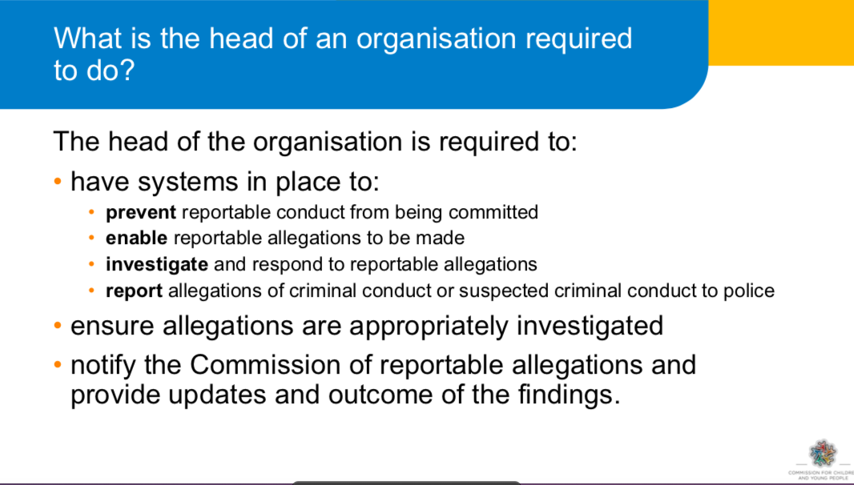

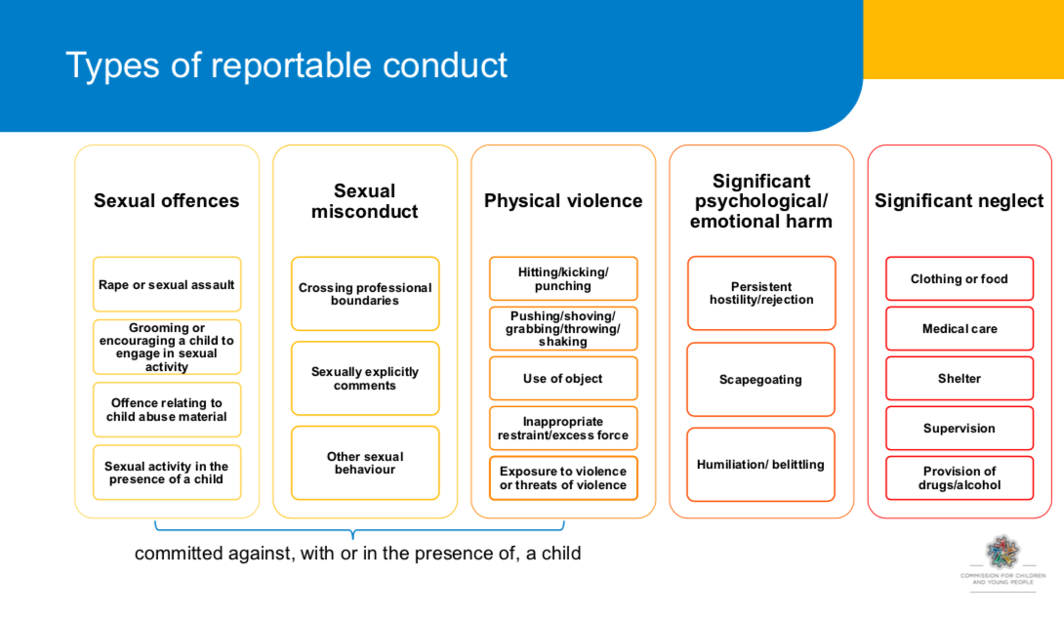

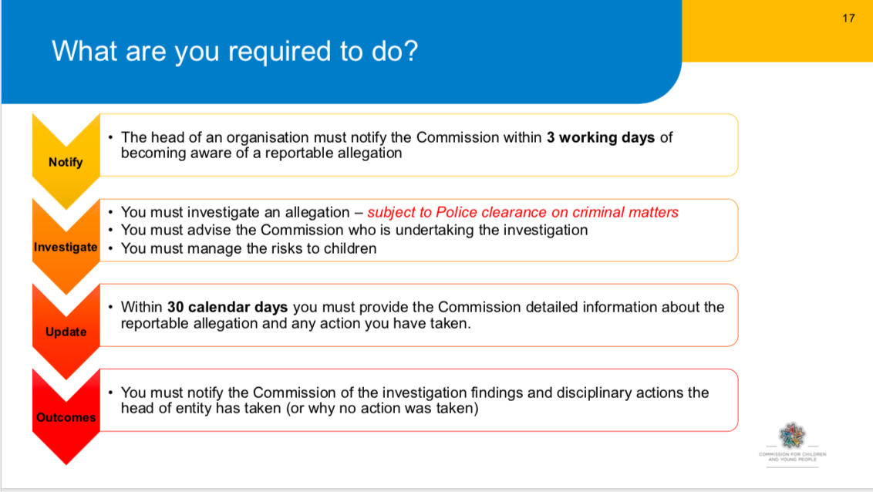

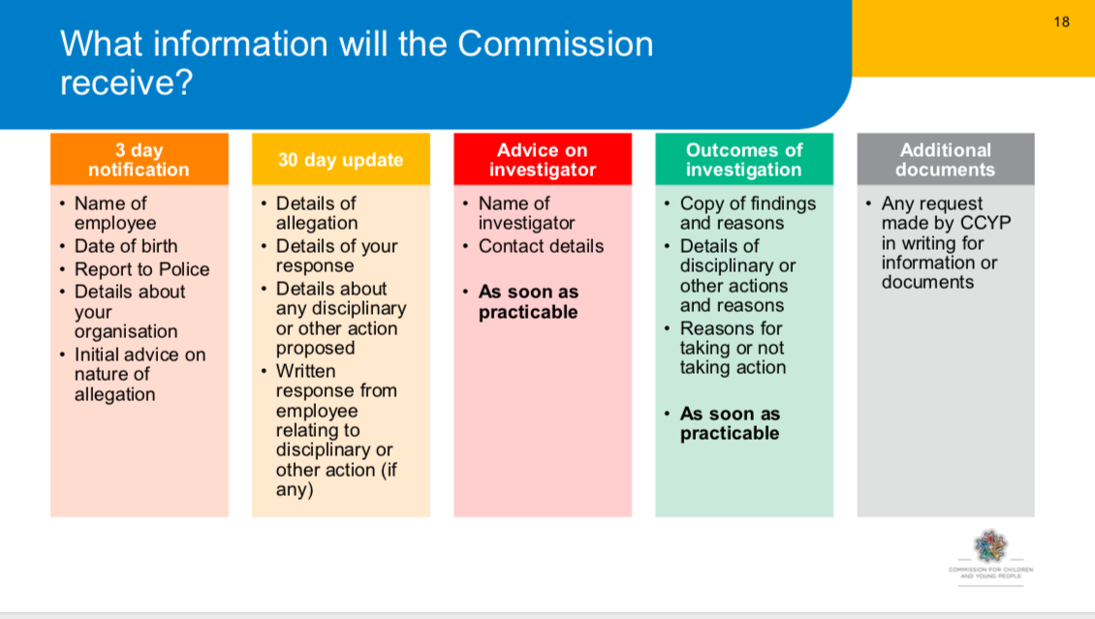

A more complete outline of the elements of the Reportable Conduct Scheme can be found at:

<https://ccyp.vic.gov.au/child-safety/resources/reportable-conduct-scheme-information-sheets/>

**APPENDIX 5 INCIDENT REPORT [Example only]**

This form is to record the details of any incident involving the writer of the report, especially where there was an accident, near miss or emotional reaction involving another person, or if the writer of this report has been accused of child sexual abuse or other misconduct.

Name: _________________________________________ Phone contact: ______________________

Date of Incident: _____/ _____ /201__ Time of Incident: ___________________am /pm

Location of Incident on Site: _____________________________________________________________

Name (s) of anyone else involved in the incident: ____________________________________________

Provide the name and contact details of any witnesses of the incident who can provide additional evidence or view.

1.Name: ______________________________________ Mobile: ______________________________

2. Name: _____________________________________ Mobile: ______________________________

Please describe what happened, your actions and/or words and the actions and/or words of others involved. Do not give your opinion about other’s motives or intentions. (PTO if necessary)

.

.

.

.

.

.

.

.

.

.

.

.

.

.

.

.

.

.

.

.

I, (Print name): ______________________________ hereby declare that what I have written is true and accurate in the details I have provided.

Signed: ______________________________________ Date: ____ / _____ /201__

**APPENDIX 6 Definitions of Abuse against Children**

**Child abuse includes:**

Any act committed against a child involving

1. a sexual offence; or
2. an offence under section 498(2) of the Crimes Act 1958 (grooming); and
3. the infliction, on a child, of-
   * 1. physical violence; or
     2. serious emotional or psychological harm; and
4. serious neglect of a child.

“Child” means a person under the age of 18 years unless otherwise stated under the law applicable to the child. Collective term for “child” is “children”.

There are five common types of abuse: physical, sexual, emotional, neglect and racial/cultural

1. **Physical Abuse**

Physical abuse is any non-accidental physical injury resulting from practices such as:

* Hitting, punching, kicking, beating (marks from belt buckles, fingers).
* Shaking (particularly babies).
* Burning (irons, cigarettes), biting, pulling out hair.
* Alcohol or other drug administration.

1. **Sexual Abuse, including ‘grooming’**
   1. **Sexual abuse** is any sexual act or threat to perform such upon another person. It occurs

when a person uses their power and authority to take advantage of another’s trust to involve them in sexual activity. It does not necessarily involve genital contact but is any act which erodes the sexual boundary between two persons. It may appear consensual but the validity of consent is negated by the power differential.

* 1. **Sexual grooming** is a pattern of behaviour aimed at engaging a child, as a precursor to sexual abuse. Examples include inappropriate special time with the child, inappropriately giving gifts, ‘accidental touching’, allowing the child to sit on lap, having secrets. In isolation, such behaviours may not indicate the risk of abuse occurring, but if there is a pattern of behaviour occurring, it may indicate grooming.

Grooming behaviours often mimic the kind of relationship-developing strategies that Christian ministries use for the benefit and wellbeing of children, that is, gaining the trust of the child, demonstrating care and concern, spending time, visiting in the home, finding out about family, friends and hobbies. However, grooming to involve a child in sexual activities for the personal gratification of an adult is a crime.

1. **Emotional or Psychological Abuse**

Emotional abuse is the chronic attitude or behavior of one person, which is directed at another person, or, the creation of an emotional environment which erodes a child’s development, self-esteem and social confidence over time. Behaviours may include: devaluing, ignoring, rejecting, corrupting, isolating, terrorising or chronic and extreme domestic violence in the child’s presence.

1. **Neglect**

Neglect is characterised by the failure to provide for the child’s basic needs. And includes any serious omission or commission which jeopardises or impairs a person’s development. Examples include the failure to provide food, shelter, adequate hygiene or schooling for a child.

1. **Bullying**

Bullying can be defined as repeated, unreasonable, unwanted behaviour conducted by an individual or group against another person, which has a negative impact on health and wellbeing. This includes aggression, verbal, emotional/psychological or physical acts or the use of social media or other forms of communication that intimidates, humiliates or threatens. It often involves an abuse of a power differential between the bully and the victim.

**Other Forms of Abuse**

1. **Racial, cultural or religious abuse**

Racial abuse is any harmful conduct that discriminates against, or demonstrates contempt, ridicule, hatred or negativity towards a child because of their race, ethnic origin, skin colour or other evidence of ‘difference’. It may be overt, such as racial vilification or discrimination, or covert, such as demonstrating a lack of cultural sensitivity or positive ideas about a different ethnicity.

Religious or cultural abuse is similar to racial abuse, but is directed towards expressions of religious faith or practice or cultural dress, identifying styles of cultural expression or practices.

*‘The harm that is caused by racial, religious or cultural abuse targets the child’s* ***identity****.’*

1. **Spiritual abuse**

This involves the perpetrator using their position of authority in the church or higher understanding of biblical teaching or God’s will to manipulate a child for their own use or benefit, or to pressure a child using guilt, shame, or a strong “works” based ethic. Illegal practices of this nature are defined in the Change and Suppression (Conversion) Act 2021 (Vic)

**Cyber-bullying**

Cyber-bullying occurs when a person uses any form of telecommunication to sexually groom, bully, suggest an inappropriate relationship be formed, or engage a child in sexual language or behaviours. The explosion of electronic communications (Facebook and other social media sites, text-messaging, internet chat rooms etc.) has seen a sharp increase in cyber-bullying.

### Statistics of Abuse

It is very difficult to know precisely the amount of child abuse that occurs in Australia, as many acts go unreported. Statistics of reported acts, though, are available through government agencies. Child Protection Australia 2010-11 report reported that there were 237, 273 notifications of child abuse involving 163,767 children in Australia..[5] The Australian Institute of Health and Welfare (2002) revealed the following breakup of perpetrators: 74% natural parent, 10% step-parent or de facto, 7% other relative or sibling, 5% friend or neighbour, 4% others (including strangers).[6] The reality of abuse in Australia is a lot worse than the statistics. There are estimates that as many as 1 in 20 men in Australia may sexually offend against a child. As many as 1 in 5 children will be sexually abused during their childhood. On average, it takes a girl 7 years to tell someone about such abuse, and for men the average is well over 25 years, if they ever do.

**APPENDIX 7 (Example) Feedback Survey of Children.**

**Name:_________________**

This survey is your chance to have a say about the children’s programs. Think about each statement and mark on the line, somewhere between “Not at all!’ and ‘Absolutely!’.

1. **I feel welcomed and looked after when I come to this church..**

I__________________________________I_____________________________________I

Not at all. Mostly Absolutely!

1. **My parents like and follow the log-in process and arrangements for my care.**

I__________________________________I_____________________________________I

Not at all. Mostly Absolutely!

1. **I know which toilets to use and feel safe when using them.**

I__________________________________I_____________________________________I

Not at all. Mostly Absolutely!

1. **There are good spaces for activities and learning times.**

I__________________________________I_____________________________________I

Not at all. Mostly Absolutely!

1. **The activities are fun, challenging and well-organised.**

I__________________________________I_____________________________________I

Not at all. Mostly Absolutely!

1. **I feel safe and relaxed while I am in the children’s programs.**

I__________________________________I_____________________________________I

Not at all. Mostly Absolutely!

1. **I feel that the leaders know what they are doing and are looking after me.**

I__________________________________I_____________________________________I

Not at all. Mostly Absolutely!

1. **The leaders are friendly and respectful of my friends and me.**

I__________________________________I_____________________________________I

Not at all. Mostly Absolutely!

1. **If I am worried or upset, I know who I can go to for help.**

I_______________________________I___________________________________I

Not at all. Mostly Absolutely!

1. **I would recommend this church program as great for kids.**

I________________________________I___________________________________I

Not at all. Mostly Absolutely!

Appendix 8

MEDICAL & HEALTH INFORMATION – SPECIAL EVENT (EXAMPLE)

…………………………….…………………**(**Insert organisation name)**

Child’s Name:

(Surname) (Christian name) Date of Birth

Is your child taking any regular or currently prescribed medication? YES / NO

If so, please name the medication and provide details of dosage and administration.

Your child’s leader will administer medication to your child as directed by written instructions from you. Please clearly mark your child’s name on all medication along with the dosage and administration procedures.

Is there anything about your child’s health which means that s/he should engage in only limited physical activity? YES / NO

If so, please give details

Does your child require a special diet because of health problems? YES / NO

If so, please give details

Is there any other information which may help us care for your child? YES / NO

If so, please give details

Emergency contact 1. Name: ___________________________________ Mobile: _______________________

Emergency contact 2. Name: __________________________________ Mobile: _______________________

Preferred Medical Centre/ Doctor: ______________________________________ Phone: ________________

Do you have private medical insurance? Provider: ________________________________________________

**AUTHORISATION**

‘In the event of an accident or sudden illness, I authorise the person in charge to call an ambulance or to seek medical attention at my expense, should I not be contactable.’

Signed: ______________________________________________ Date: ___/____/20___

Parent/guardian/caregiver [Print name if not one of the above] _______________________________

Witness Name: _______________________________ Signature: _____________________________________

Appendix 9 Permission Form

PERMISSION TO ATTEND EVENT/CAMP FORM (EXAMPLE)

…………………………….…………………**(**Insert organisation name)**

As a parent/caregiver of:

I, give my consent for him/her to take

part in the <special activity or camp> to be held at the (event site)

from to (or on )

*(date) (date) (date)*

I have seen the attached copy of the programme for the (event)

and acknowledge that risk of injuries is inherent in physical activities. While I am aware that staff will take all due care, I recognize that accidents may occur.

The staff and supervisors have my authority to take whatever action they think necessary to ensure the safety, wellbeing and successful conduct of the participants as a group or individually in the above-mentioned activity.

If my child becomes ill or is accidentally injured, I authorise the person-in-charge to obtain on my behalf whatever medical treatment my child requires. I will agree to pay all such medical expenses.

I have attached information as asked concerning my child’s health including any relevant details of his/her limitations for the planned activity. My child’s own local doctor or medical specialist may be contacted in an emergency.

I also acknowledge that the <Church> and all its representative leaders or other helpers at <name of event> can accept no liability for any personal injury or property loss suffered by my child during the period of the <name of event>.

Signed: __________________________________________________ Date:___/____/20___ Parent/Guardian/Care-giver

Appendix 10 MINISTRY/ORGANISATIONAL COVENANT

**Of <Church>**

I, ______________________________________________

(Print name)

1. Declare that, except as is stated below,

(1) have not been guilty of any sexual misconduct against any person;

(2) have never committed any criminal offence involving fraud, violence or drugs;

(3) am of good character and suitable for ministry within **<Church>**.

(If exceptions to the above give details and if insufficient room place them in an attachment).

2. Acknowledge I have read and agreed to the <church’s> Child Protection Policies, Code of Conduct and the Child Protection Manual of Procedures.

1. Agree I will cooperate with the **<Church>** in any investigation undertaken in relation to a complaint or allegation of impropriety or misconduct made against me.
2. Agree I will attend and take part in education courses to prepare and equip me for ministry with children.
3. Acknowledge that by signing this covenant no legal contract is created between myself and my **<Church>** but accept that it acts as a consent for the operation of the Child Protection Policy and the Child Protection Procedure Manual and that legal consequences may follow if I have knowingly given false answers to any of the questions 1 – 4 above.

Signature: Witness:

Full name: Name:

Address:……………………………………………………………………………………… Date: ………………………………..

1. It is recognized that no organisation can guarantee the safety of children and other vulnerable people who are on site at a venue. The term ‘child-safe’ means that child safety is paramount to this organisation, that it has compliant policies and procedural documents and that risk identification and mitigation practices are embedded in the culture.
2. The governing body is the leadership group of your community. It might be called the Board, Eldership, Church Council or another title. This is the legal entity responsible for determining culture and approving policies.
3. This check is now (as of July 26, 2022) an online service of the Victoria Police which can only be applied for by the person, not the organisation. There is a small cost involved. Churches can apply for a Community Volunteer Fee number, which will reduce this cost, if quoted by a volunteer.
4. It is important to have an arrangement in place. The investigator must be a person of experience and qualification, maybe with a role in the wider church association or sourced through GJIC Insurance.
5. NSW and Act Baptist Churches, *Creating Safe Spaces Manual 2012 v1.3, p11*
6. Ibid.